**Building a web project - Login page**

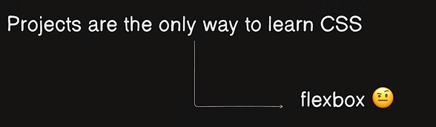

1. Flexbox allows us to position certain element at a certain position in the webpage.

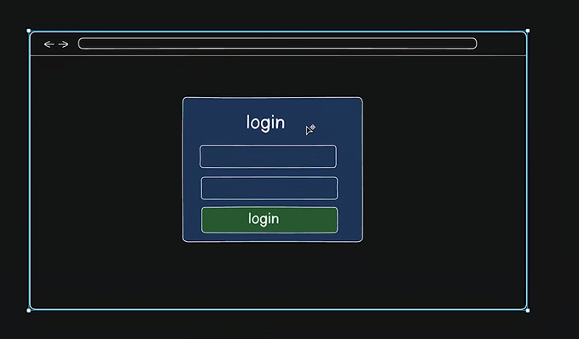

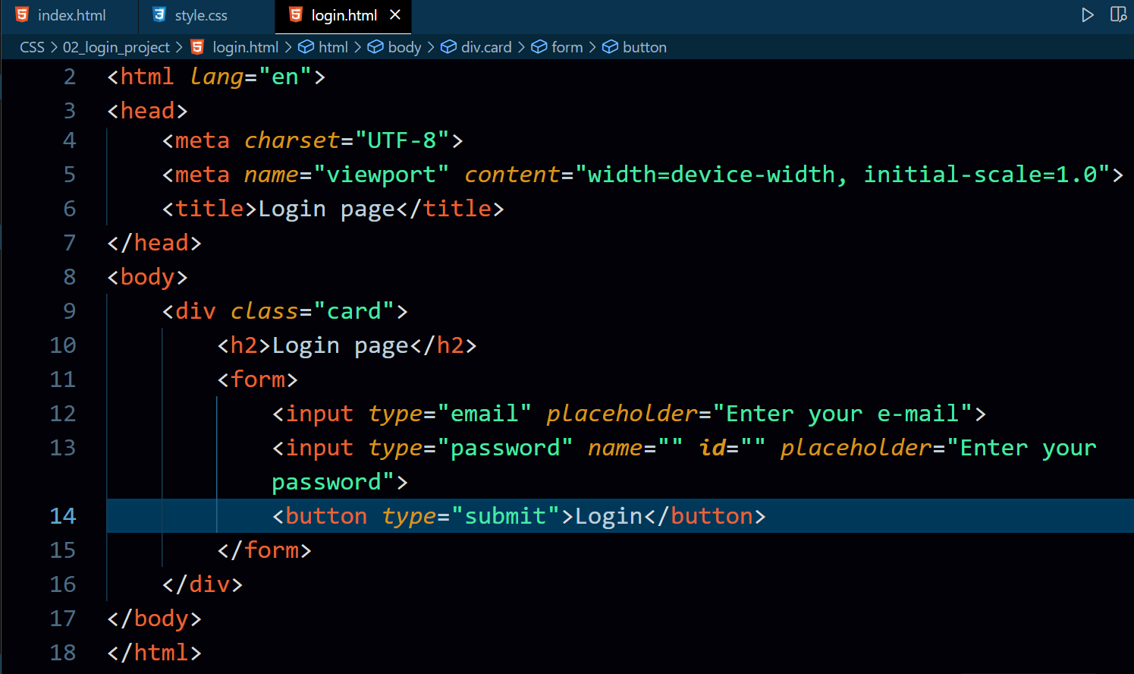

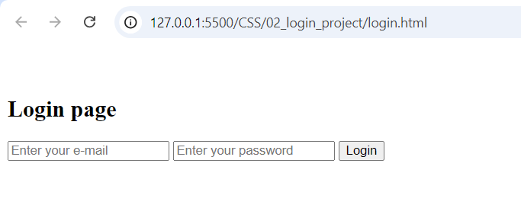

1. div.card + tab => <div class=”card”></div>
2. input:email + tab => <input type=”email” name=”” id=”” placeholder=”email”>
3. button:submit + tab => <button type=”submit”></button>
4. 100% vh(viewport height) refers that developer is demanding 100% of the screen device height for the element. 50%vh refers to demanding only 50% of screen device height for the element.

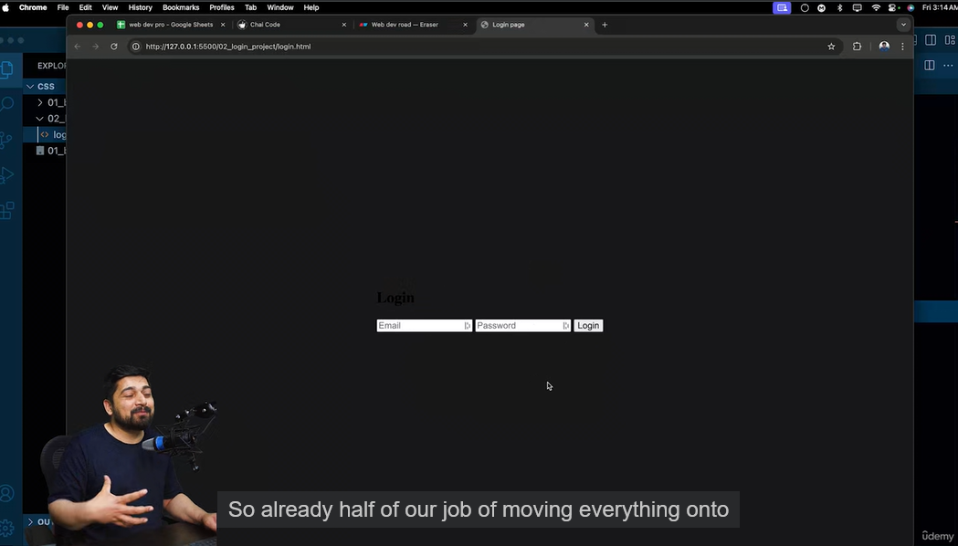

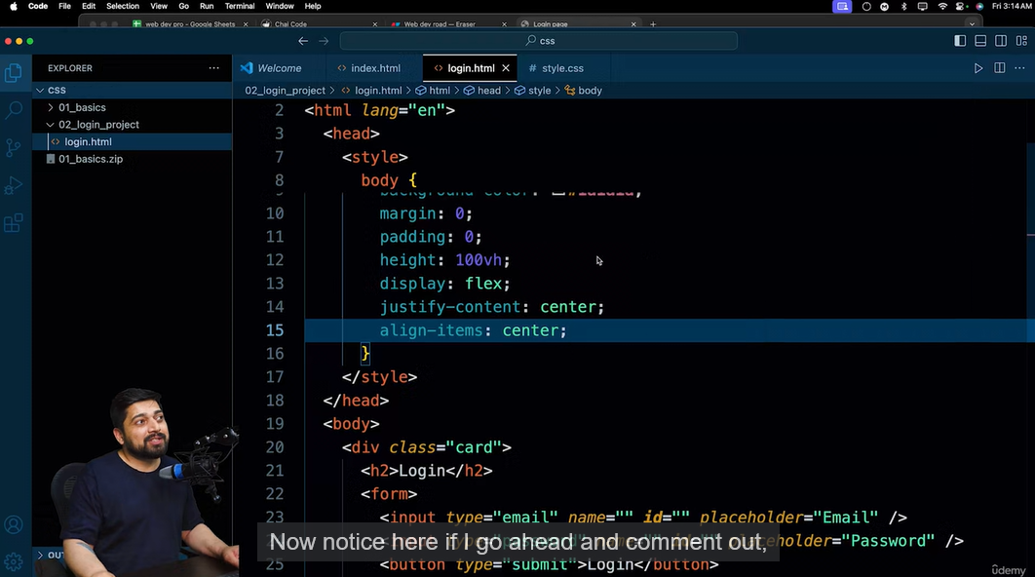

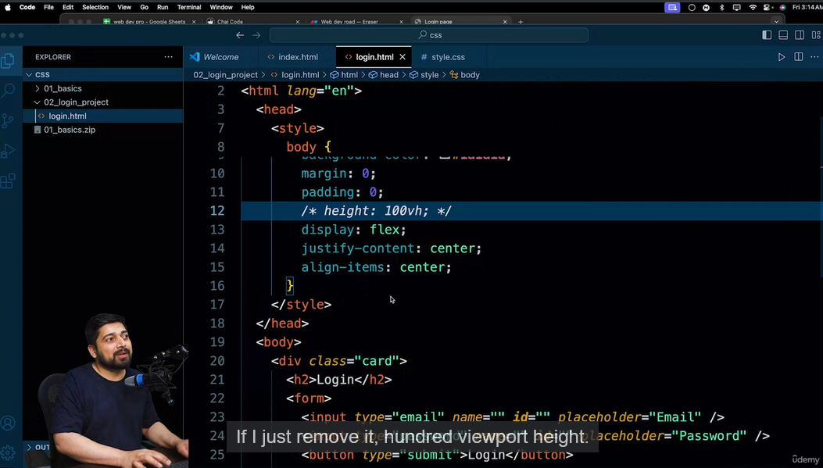

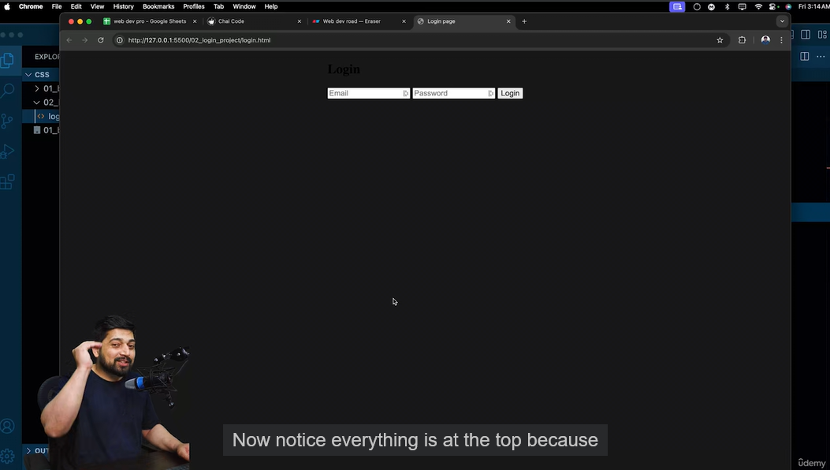

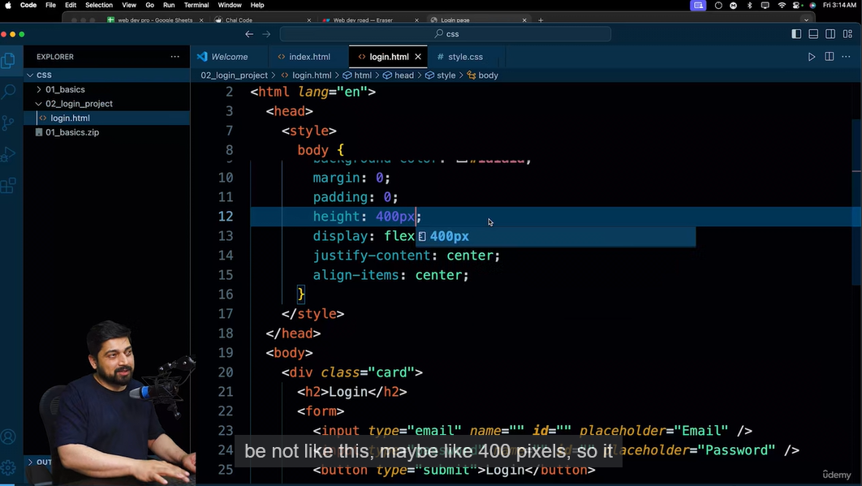

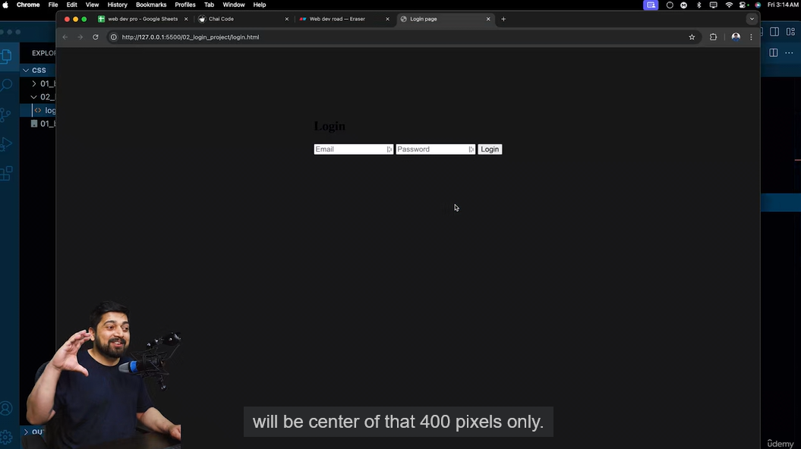

1. Ask the designer about border radius dimension/measurements.

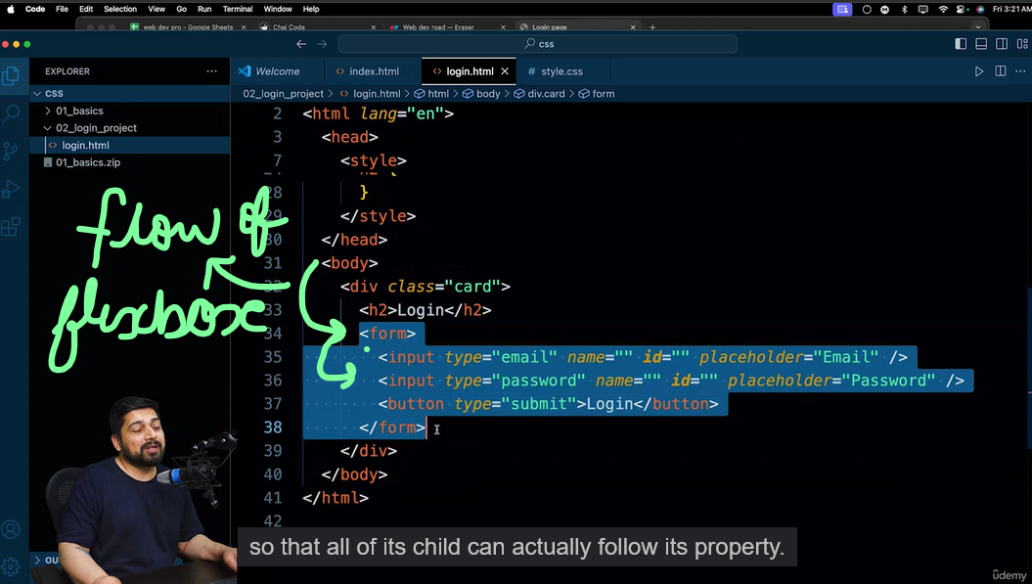

1. Flexbox property comes/originates from parent element to child element, i.e. if the parent element doesn’t have flexbox, child element cannot directly use it.

